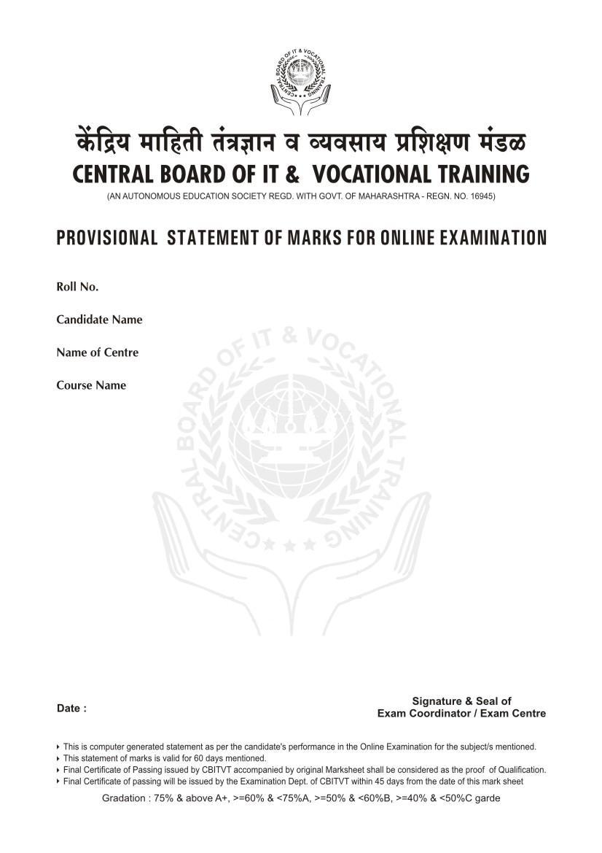
782011
shah khushboo
MLK Center
Advance Certificate in Data Processing (ACDP)
Subject | Maximum Marks | Marks Obtained | Remarks
MS Excel  MS Vista  MS Word | 100 | 0 | Fail
Grade : C Total : 0/100

14/09/2011

